

Creating a Workflow for RSP Microcode in Linux

Tutorial by CrashOveride

This tutorial attempts to assist with installing a toolchain to create graphics ucode (ucode=Microcode) for use on N64.

Requirements:

A VM or Machine with a linux distro that supports the iQue SDK (I will be using Fedora 10)
The iQue SDK installed (If it’s not already, read index.html)
A way to test on real HW (e.g. EverDrive, 64Drive, N64 Blaster)

Step 1: download ucode

The RSP code will be in some “leaked files that make you go Oh man” in the usr/src/pr/rspcode folder.
You can put these anywhere, but I will be putting them in home/crash/tutorial/rspcode.
Step 2. Fix RSPBoot Code

Most distros come with dos2unix, but if not, install it.

Then open a terminal
Do

cd ~/tutorial/rspcode/rspboot

then do

dos2unix Makefile
dos2unix *.s
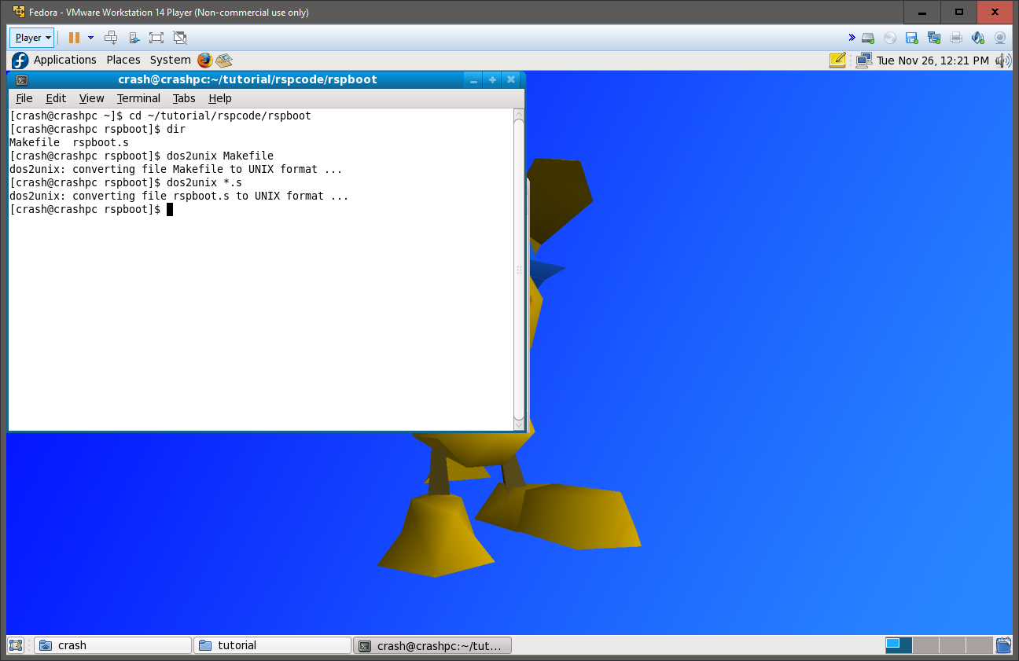
Then you can safely type “make”
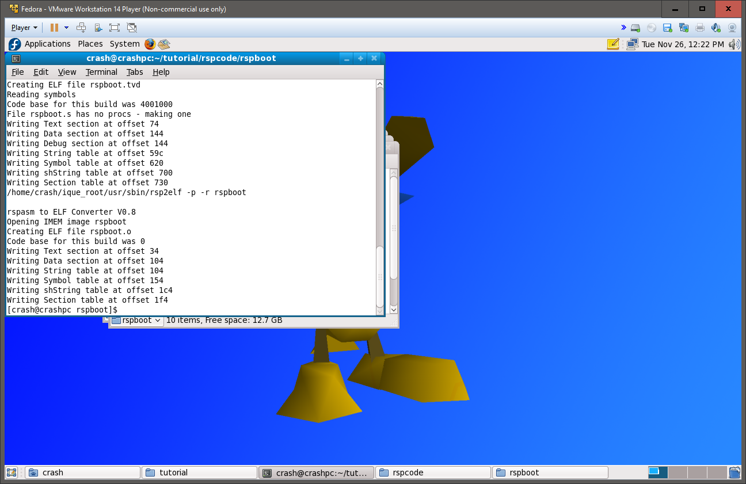
And you will have the assembled rspboot.o in the folder.
Step 2: Audio Microcode

The audio microcode is also easy to fix.

Do
cd ~/tutorial/rspcode/audio
Then convert the files to UNIX encoding by

dos2unix Makefile
dos2unix *.s
dos2unix *.h
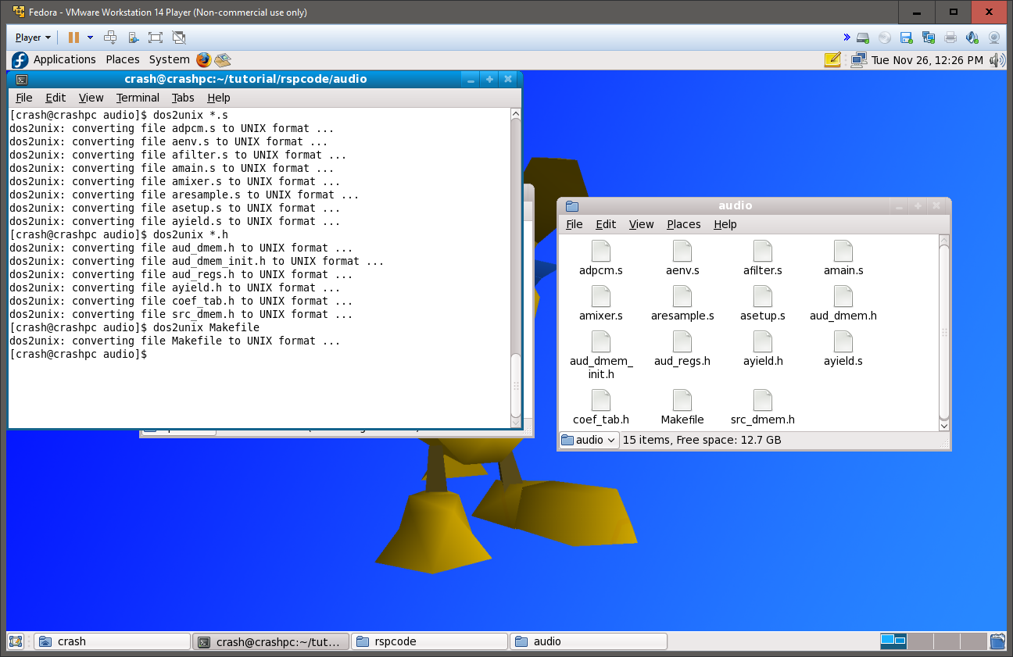
Then run make
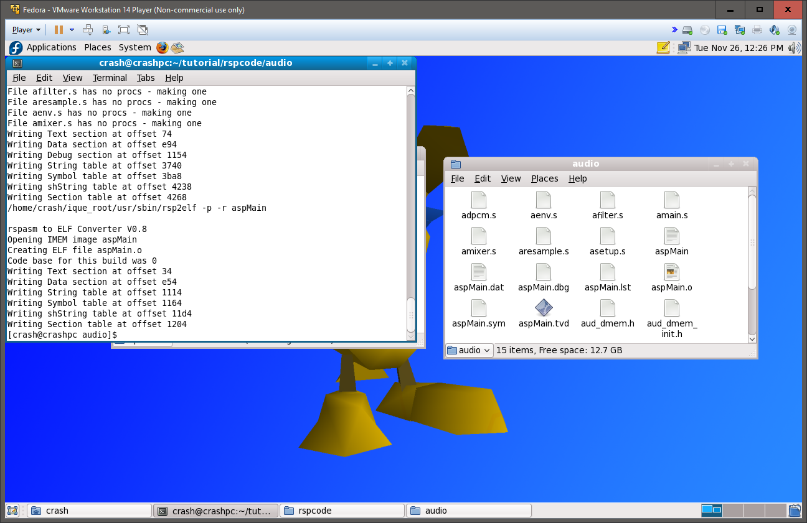The assembled ucode will be in aspMain.o

Step 3: Graphics ucode

Fixing graphics code requires a few more steps.

First we must convert all source files to UNIX.

Do
cd ~/tutorial/rspcode/graphics
Then do
dos2unix Makefile
dos2unix *.s
dos2unix *.h
dos2unix *.c
Then cd into each seperate ucode folder and convert all files in them

Example:
cd Fast3D
dos2unix Makefile
cd ..

We’re not done yet however, now we need to fix bugs in the source in order for it to assemble.

First do

gedit gmain.s

Then go to the line which says
#include "newt.s" */
And erase the */ and save and exit.

Then
gedit goverlays.s

and go to the line which says
#include "gflight.s" # do lighting
And erase # do lighting
Then save and exit.
Then change permissions of “sizecheck” and “labeltest” to allow reading and writing (doing this may be different on your distro)
Then open both in gedit and change
#!/bin/ksh to #!/bin/bash

Lastly, open fillnops.c in gedit (yes there is C code)
And add below #include <stdio.h>
#include <stdlib.h>

And save and exit.
Then you can safely type in “make”
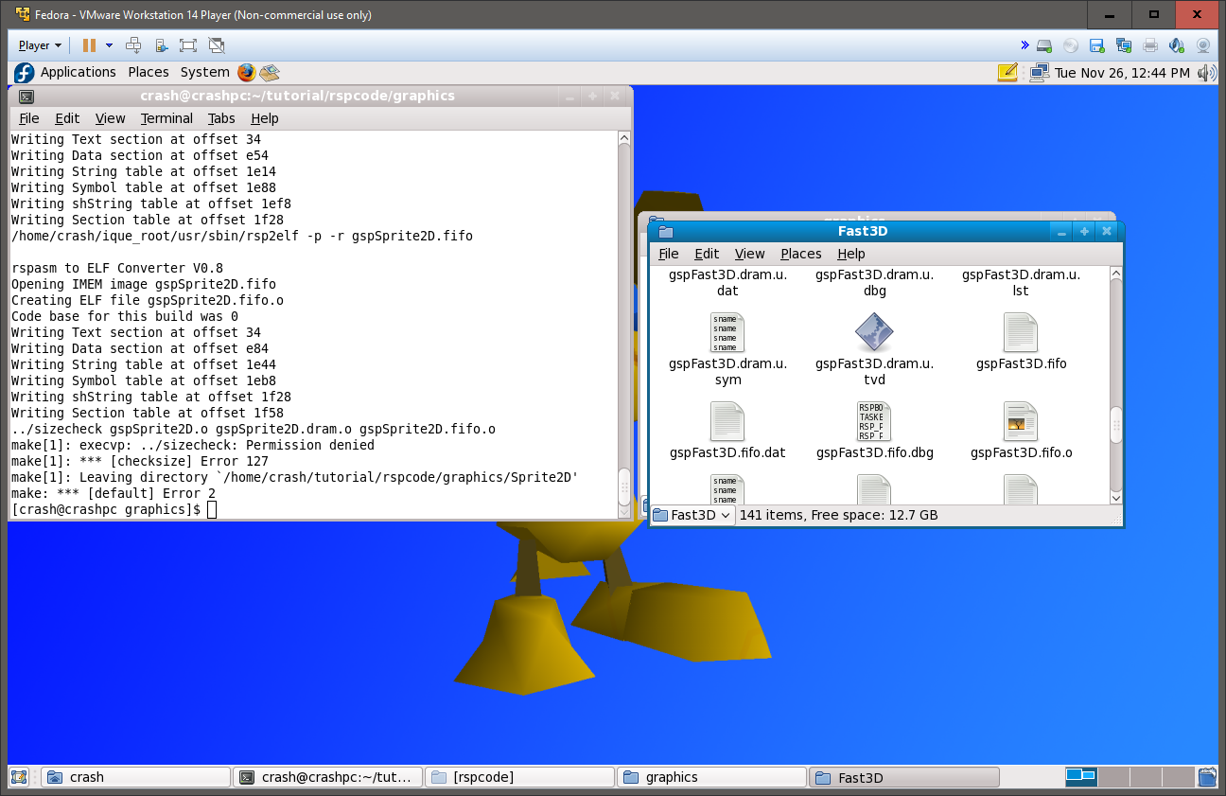
You may get labeltest or sizecheck errors but you can ignore them.
All microcodes are compiled and can be accessed in relevant folders.
You have now finished the tutorial and have a working official RSP ucode toolchain.
Future writings by me or Olivieryuyu will help with editing the code.

Credits:
SGI for making original assembler programs
Nintendo for the N64
Broadon/Routefree for porting the IRIX SDK to Linux
Olivieryuyu for doing the hard work of fixing the graphics ucodes to actually compile
jrra for showing us that we had to define ROOT

